**DAILY ONLINE ACTIVITIES SUMMARY**

|  |  |  |  |  |  |  |  |  |
| --- | --- | --- | --- | --- | --- | --- | --- | --- |
| **Date:** | **05/06/2020** | | | | | **Name:** | **Katira Krishna J** | |
| **Sem & Sec** | **8th A** | | | | | **USN:** | **4AL16CS045** | |
| **Online Test Summary** | | | | | | | | |
| **Subject** | | **BDA** | | | | | | |
| **Max. Marks** | | **30** | | **Score** | | | **14** | |
| **Certification Course Summary** | | | | | | | | |
| **Course** | **Hadoop101** | | | | | | | |
| **Certificate Provider** | | | **Cognitiveclass.ai** | | **Duration** | | | **5 hours** |
| **Coding Challenges** | | | | | | | | |
| **Problem Statement: Python program to separate odd and even elements in a given list in two different lists** | | | | | | | | |
| **Status: Completed** | | | | | | | | |
| **Uploaded the report in Github** | | | | | **yes** | | | |
| **If yes Repository name** | | | | | **Krishna_Katira** | | | |
| **Uploaded the report in slack** | | | | | **yes** | | | |

Online Test Details:

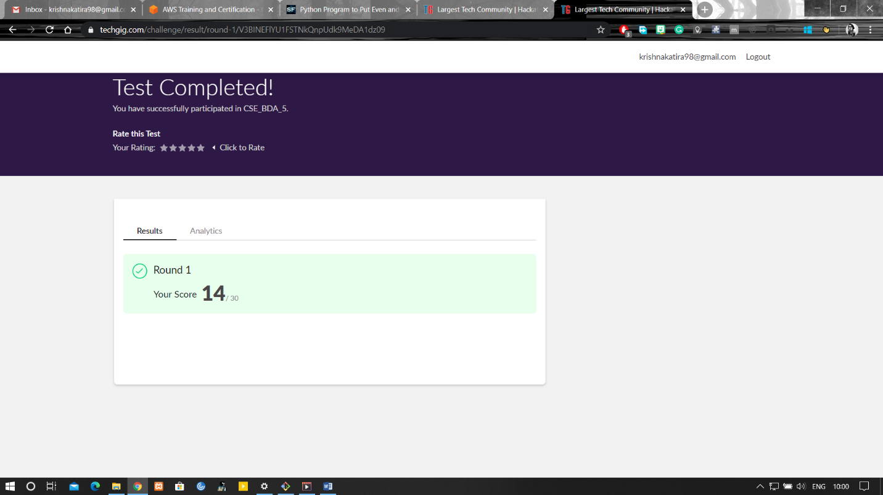

Certification Course Details:

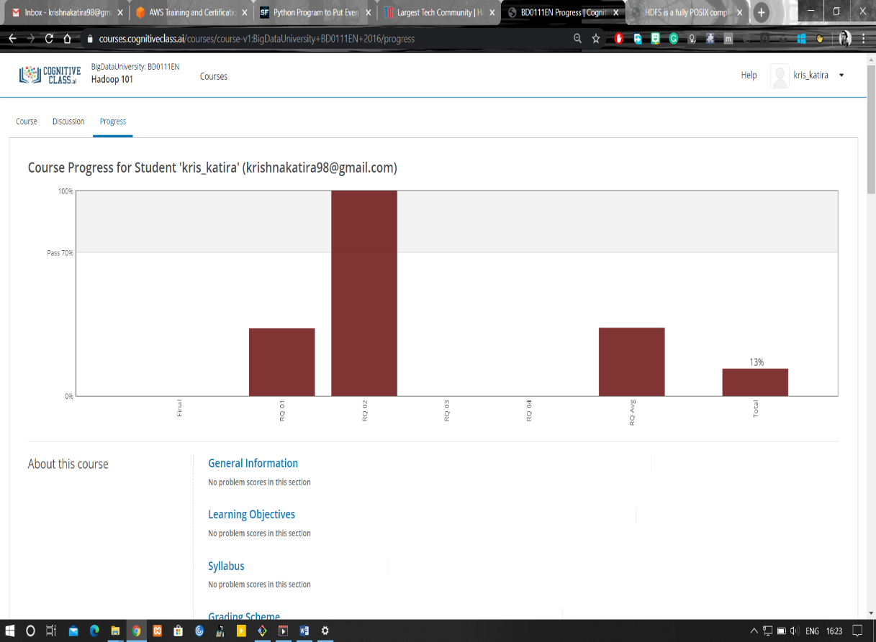

Coding Challenges Details:

**program1**

a=[]

n=int(input("Enter number of elements:"))

for i in range(1,n+1):

b=int(input("Enter element:"))

a.append(b)

even=[]

odd=[]

for j in a:

if(j%2==0):

even.append(j)

else:

odd.append(j)

print("The even list",even)

print("The odd list",odd)